**SuperMed Hospital Software**

**Tel: 0208822788**



**A brief introduction of our hospital software - for your kind consideration.**

**CONTENTS**  
- Introduction  
- Benefits of using SuperMed Hospital Software  
- Problems of other software that we have solved  
- Answers to some frequently asked questions  
- Our Core Principles  
- Technical Features  
- Documentation, Support, Training

* Pricing, Payment terms
* Contact Details

**INTRODUCTION:**

SuperMed was developed by Dr Hamza Bawumia a medical doctor and Computer Programmer with over 10 years of programming experience.

“ The idea of SuperMed came out of the daily frustrations that I (Dr Hamza Bawumia) encountered while working with another hospital software in a private hospital. The software was very unstable and often crushed several times while clerking my patients. The interface was also ugly and boring to work with so I decided to build my own.”

It took exactly 3 years of hard work and many sleepless nights to come up with this superior hospital software called SuperMed.

SuperMed Hospital Software was built using the world renowned Computer programming language called Python and it leverages the award-winnng Django Framework developed by a high-level group of computer programmers consisting mainly of PhD holders.

The Python-Django framework is respected all over the world for its stability and high performance as well as its superior security features and it is now currently used by top universities like MIT and Harvard for their educational platform. In fact, the security features of Python-Django framework were developed by seasoned programmers at MIT and Harvard in collaboration with Google.

It is therefore no wonder that Python-Django Framework was chosen as the platform upon which to build SuperMed Hospital software.

**BENEFITS OF USING SUPERMED HOSPITAL SOFTWARE**

1. Improvement in patient clinical work flow, billing, and revenue generation cycles.

2. Improvement in information storage and retrieval plus reduced cost on stationery and paper work.

3. With our **inventory system**, there is improved quality of administering, managing and controlling of drugs at the dispensary.

4. High quality and fast reporting to management and external user agencies

5. Reduced patient service waiting time

6. Improved administrative decision making

7. Provides quick, easy and secured access to information and data

8. Improves revenue generation cycle and reconciliation.

9. With our integrated NHIS system you can generate claims with less effort

**PROBLEMS OF OTHER SOFTWARES ON THE MARKET**

We collated the various complaints that people have about other competing software on the market. Then we worked on them so that our software will avoid these pitfalls. Today SuperMed has solved all these common problems and stands out as the leading Medical Software on the Market.

Here are some of the Problems/ Complaints from users of other medical software.

|  |  |
| --- | --- |
| User **Complaints about Other Medical Software** ( from various hospitals) | Our Solution to these Problems |
| Complaints about Other Software on the market  **LABORATORY DEPARTMENT**   1. Lab entry form is not user friendly on some other software.   Complaints about Other Software on the market  **NHIS CLAIMS DEPARTMENT**   1. E-claims system is not available on some other software. 2. Claims coding (status options) are not available on some other software.   Complaints about Other Software on the market  **DOCTORS/ PRESCRIBERS:**   1. Duplicate tests or Repeat Labs are not available on some other software. 2. The system has problems anytime there is a update on some other software. 3. Certain drugs don’t come with the appropriate dosing units on some other software 4. The system should allow for editing of prescriptions at least within 24hrs in case there is a mistake 5. The system should allow drugs that are not on the system to be put in the prescriptions so that nurses can chart during drug administration.   Complaints about Other Software on the market  **ACCOUNTS DEPARTMENT:**   1. Ward billing is not available on some other software   Complaints about Other Software on the market  **PHARMACY DEPARTMENT:**   1. Substitution of drugs and change of drug quantities is not available for dispensers. The system picks the quantity captured form the prescriber only. 2. Duplicate drug names in the system 3. Daily Sales Report must show total drugs issued, selling price, and total amount sold.   Complaints about Other Software on the market  **STORES:**   1. Daily report showing total quantity of items issued and total cost of items issued.   Complaints about Other Software on the market  **MATERNITY DEPARTMENT:**   1. Software does not have ANC Register, Delivery Register, post natal register. 2. Post Natal Consultation is not available 3. The system is not stable and it often freezes. 4. The process of admitting patients on the system is too cumbersome 5. Labour Management is not user friendly. | SuperMed provides 3 options to enter lab results.   1. You can do manual entry if you like 2. You can scan and upload the results 3. You can just copy the results from your machine with a pendrive and paste into SuperMed. (if your lab machine allows for data copying)   E-claims system is fully functional on superMed  SuperMed has claims status options so claim officers can know which claims have been completely processed and which ones need to be worked on.  SuperMed allows for duplicate or repeat labs and it bills appropriately.  SuperMed updates don’t cause problems because they are tested before we bring them to you.  On SuperMed, the dosing units are entered by the prescribers themselves so there are no restrictions.  SuperMed allows for editing within 24 hours by authorized users.  SuperMed allows prescribers to add medications to the system.  SuperMed has a comprehensive Ward Billing System  SuperMed allows for drug substitution by authorized persons.  Also the quantity dispensed is captured only from the pharmacy hence the stock updates are always correct.  SuperMed uses a unique convention to prevent duplication of drug names. The drug names by convention will have the scientific name and the supplier name – ( just like your first name and surname ) thus making it unique. Therefore, the system will not allow any duplication.  SuperMed provides all these reports and more.  SuperMed provides all these reports and more.  SuperMed has the ANC Register and Delivery Register.  SuperMed has Post Natal Consultation on the system.  SuperMed is very stable with an uptime of 99.99%  SuperMed admission process is simple (just one click and you are done)  SuperMed makes labour management very user friendly. |

**FREQUENTLY ASKED QUESTIONS**

Here are some of the Frequently Asked Questions that people ask whenever we talk about SuperMed Software.

|  |  |
| --- | --- |
| Questions | Our Responses |
| 1. Does the software support attaching files (pdf, jpeg...) to a clients electronic folder? 2. Is the software user friendly? 3. Regarding the lab results, are they keyed in manually or interfaced with the various analyzers? 4. Aside the NHIS, are private insurance companies factored into the system? 5. Have you incorporated special clinics eg. Ophthalmology in clerking section? Such clinics have their own format for clerking. 6. How about the theatre (can we enter operation notes, etc.) 7. Can we use the hospital billing sheet on your software? 8. Do you provide after sales service and support services. 9. Is your system secure ? 10. Can all users access every part of the system? 11. Does your software have pricing policies. So we can charge different prices to different insurance companies. 12. Are doctors able to see the stock levels of drugs when they are prescribing? 13. Can the pharmacist send a message to the doctor through the system? 14. Does your software include the Maternity Department? | YES, you can attach radiology reports, x-ray pictures, etc.  YES, it is very user friendly and you don't have to "fight" with the software in order to get things done  We have all three options available to choose  1. You can key manually if they want.  2. You can scan the print-outs from the analyzers and upload directly. (This is our recommended method)  3. If the Analyzer has the computer connection port, then we can interface directly with the analyzer.  YES that is a major feature on the system. We even have different pricing plans for different insurances.  YES, we have incorporated special clinics into the system. Including Dental Clinic and Maternity.  Operation notes are added as part of the patient's review notes. And it forms part of the patient’s records.  YES, the billing sheet has been incorporated into the software  YES, we provide after sales support.  Yes our system is very secure. In fact, it is built upon on of the most secure frameworks in the world. Kindly search for **Django Framework** on the internet and see for yourself.  NO, There is an authentication and authorization platform that gives access to only certain parts of the system depending on the user settings.  YES, there are options for different pricing plans. Hence patients can be billed differently based on the kind of insurance they are using. This is can be easily configured by the hospital administration.  YES, doctors are able to see the stock levels of drugs. Hence they can select alternatives when one drug is finished.  YES, there is a private messaging system. Hence the pharmacist can send a private message to a specific doctor if there is confusion about a prescription.  Indeed, the messaging system is for all users. For example, the administrator can send a message to the doctor or to anyone else on the system and vice-versa.  YES, it covers everything from Antenatal to Delivery. It even has the Partogragh for Labour. |

**OUR CORE PRINCIPLES:**

1. **Simple is better than Complex:**

We use a simple and intuitive user interface that is consistent with modern international web browsing standards.

Logged in users are able to access any part of the software with no more than 3 clicks

2. **The End User must have an input in the software development**

Most software are developed by programmers without seeking much input from the users.

Hence the final product rather makes the users’ work more difficult although it may seem more modernized.

We believe that end users should give feedback to programmers so that the software can be adapted to fit the needs of the user. This is called user directed software development.

**OUTSTANDING TECHNICAL FEATURES:**

1. Excellent Inventory/Stock Management System for the Dispensary
2. Complete wireless network installation - hence there are no ugly long cables around your premises.
3. Web browser interface - hence any operating system can be used Windows, Linux, Apple OsX etc.
4. Mobile and Tablet compatible - hence anyone can browse the system even on a phone or tablet.
5. User friendly and flexible
6. High data security, protection and integrity
7. Easy customization and configuration
8. We provide continuous user support and maintenance
9. Hundred Percent (100%) NHIA Electronic Claims Compliant

**DOCUMENTATION, SUPPORT, TRAINING**

SuperMed comes with a video training disk that provides a step-by-step guide for new users. The videos will be copied onto your computers so that new users can learn on their own and old users can always revise anytime they want to refresh their minds.

You can even find our training videos on YouTube.com, kindly search for **Supermed EMR** and you will find all our videos online.

We also provide in-house training to hospital staff on how to use the software.

Our simple user interface (shown on the front page) makes it easy for most users to start using the system within 5 minutes or less after initial introduction. This is consistent with our core principle of “simple is better than complex”.

We can provide technical support via remote access. Hence we can provide security updates and maintenance services from anywhere in the world using the modern Remote Desktop and Team-Viewer technologies. This means that we are always available to provide technical support and updates without the need to drive to your facility every time.

**PRICING:**

Our low pricing policy has been one of the biggest selling points of SuperMed Software.

Supermed Software has an installation fee of **only 4,500Ghc for small clinics.** There is alsoan annual license fee of just 1,000Ghc/year for maintenance and updates to guarantee your total peace of mind without any additional charges.

The price for Medium sized Hospitals and Big/Tertiary Hospitals ranges from **10,000Ghc to 25,000Ghc,** depending on the patient numbers and database requirements. There is alsoan annual license fee of just 1,000Ghc/year for maintenance and updates to guarantee your total peace of mind without any additional charges.

We are so confident of our software that, **we offer FREE TRIAL for 1 month** before you pay for the package.

**CONTACT US:**

Should you be interested our Hospital Software, please do not hesitate to contact us for a real life demonstration of the Software and further arrangements for installation and subsequent use at your facility.

Tel: 0208822788 or 0244693643

**Some Of Our Satisfied Clients**(SuperMed Software)

**Bloom Medical Center** – East Legon, Greater Accra

Tel: 0200300015, 0207694991

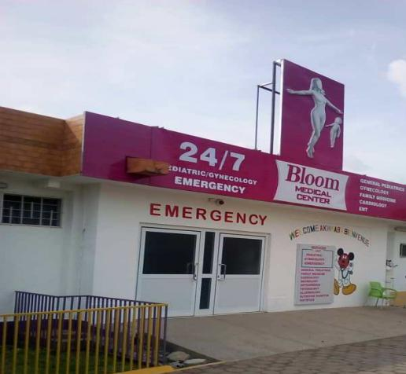

**ProLife Medical Center** – Teshie, Greater Accra

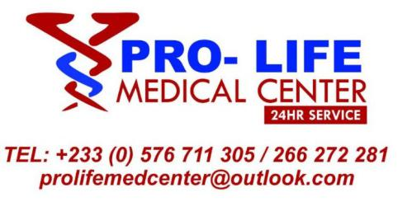

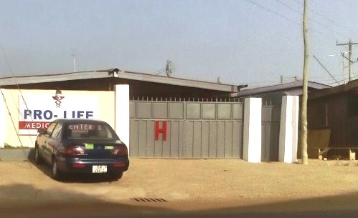

**Kotoku Medical Center –** Kotoku, Greater Accra  
 Tel: 0546363262

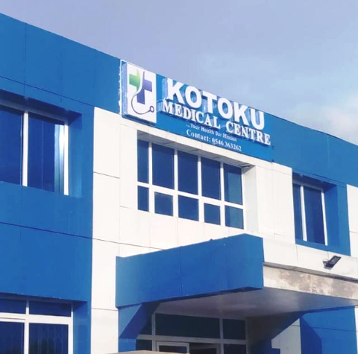

**NabStar Clinic –** Ashaiman, Greater Accra

Tel: 030 291 6207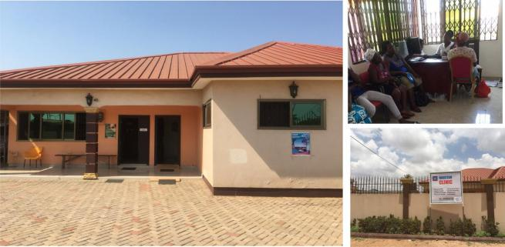

**EFAN VICTORY CLINIC** – Spintex Road, Greater Accra

Tel: 0208412921

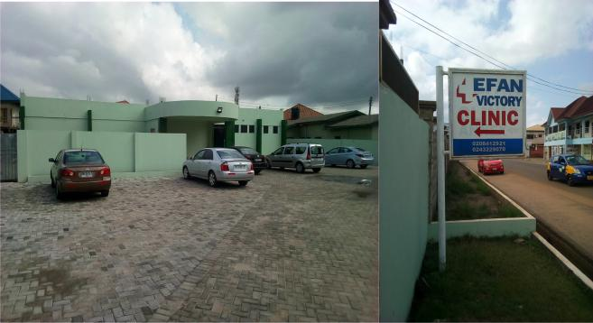

**Neptune Medical Center**

Tel: 0244-523992, 0303-413950

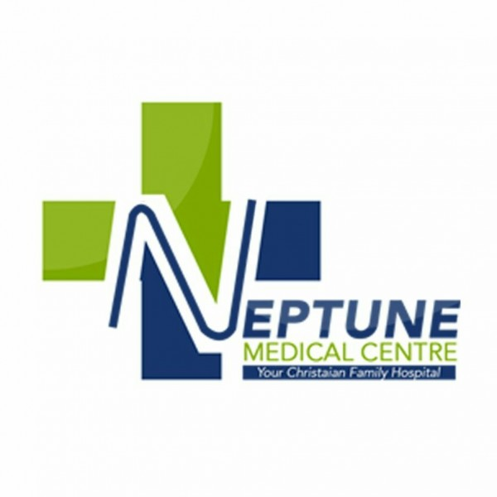

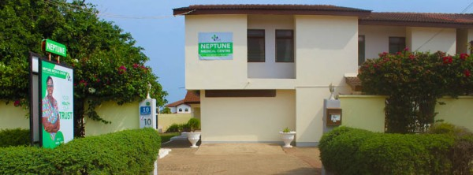

**YASSEEN HOSPITAL –** Wa, Upper West Region

Tel: +233(0) 392093808

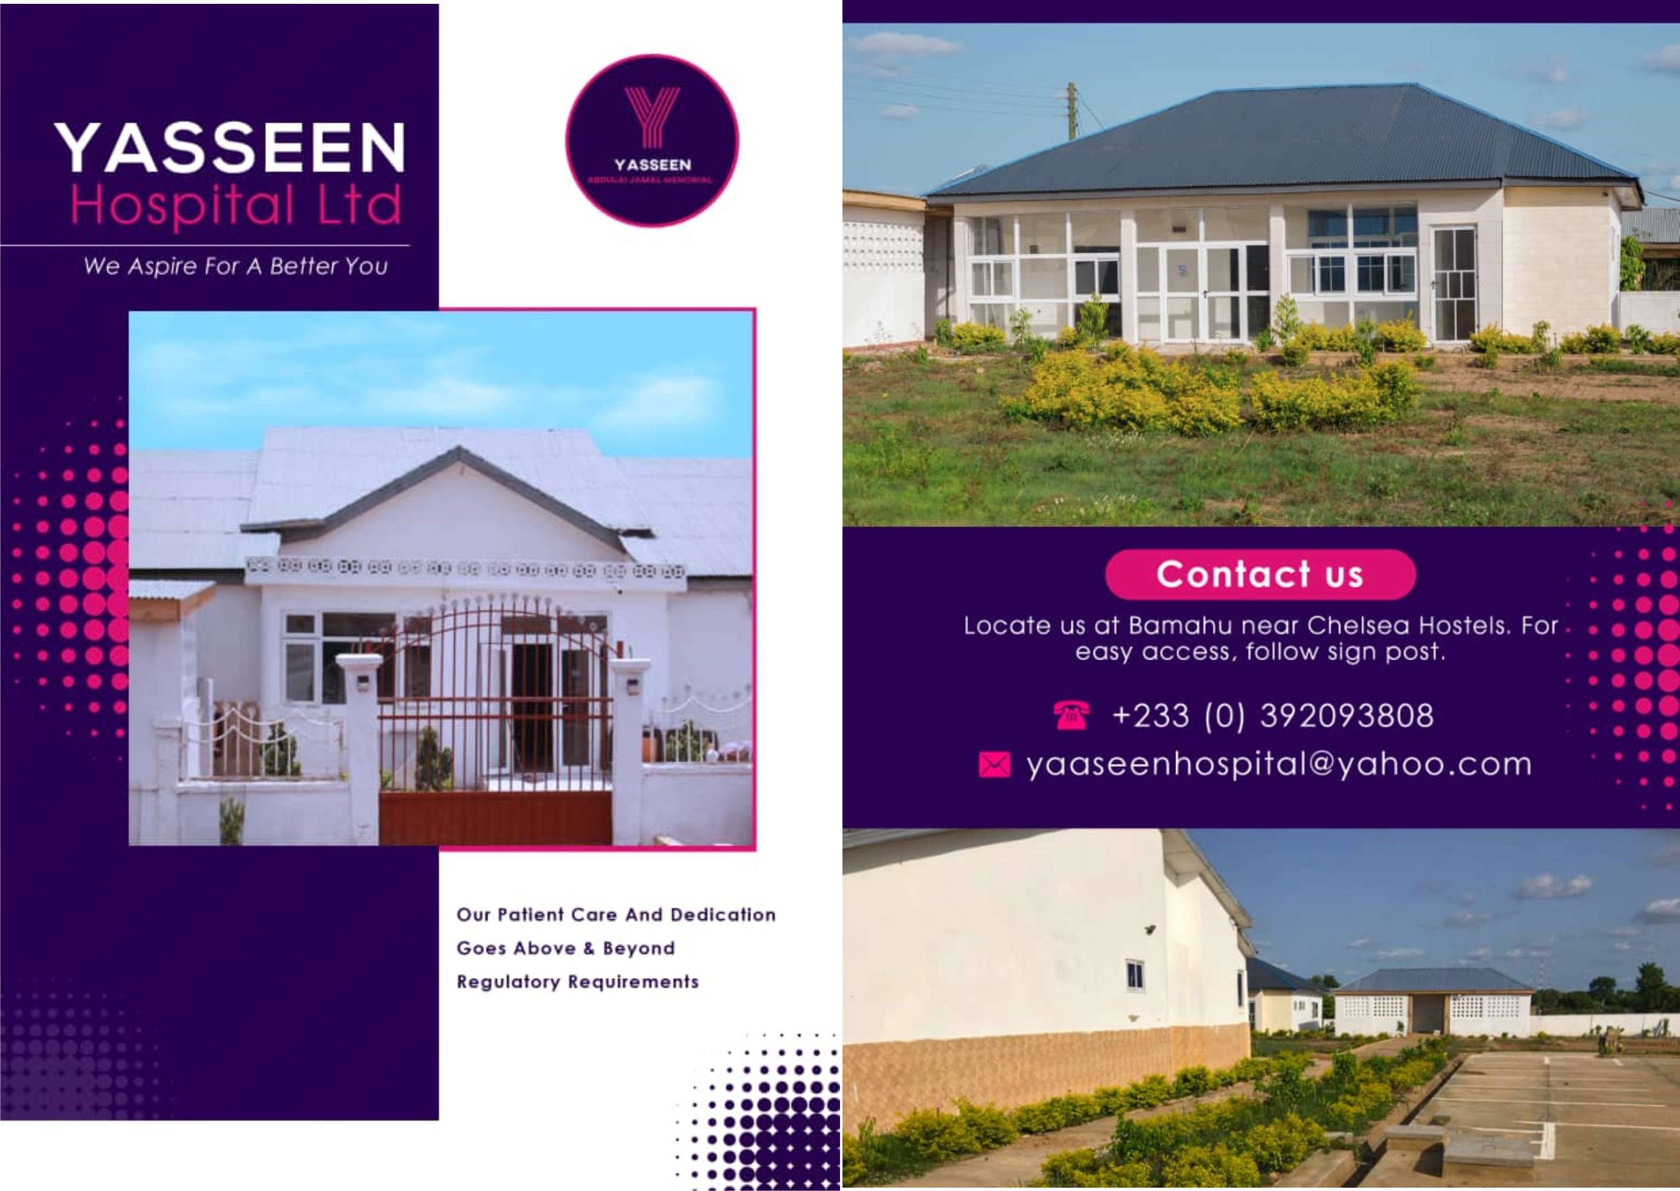

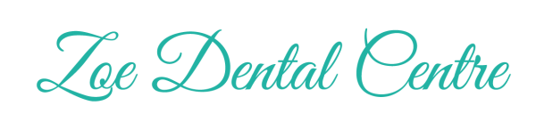

**Zoe Dental Center –** Dzorwulu, Greater Accra

Tel: 050 580 6719

